***Chinese Community – Focus Group Results***

A focus group with members of Seattle’s Chinese community was conducted on May 10, 2013 with the Chinese Information and Service Center (CISC) in Seattle located in the International District. This was part of the *Information Technology Access and Adoption in Seattle: Progress towards digital opportunity and equity* study conducted by the City of Seattle. Twenty-four individuals attended the focus group, in addition to four bilingual note-takers and a bilingual facilitator. Twenty participants completed at least part of a brief written survey. Participants engaged in the planned focus group activities – a dynamic method that relies on *mutual interviewing* among the community members – with apparent interest and engagement. Each table emphasized a specific topic, gathered information about that topic from all focus group participants, and held discussions at their tables about what they had learned during their mutual interviewing, and then reported their findings to everyone. Finally, the note-takers and bilingual facilitator gathered for a debriefing session to further detail what they had heard and learned.

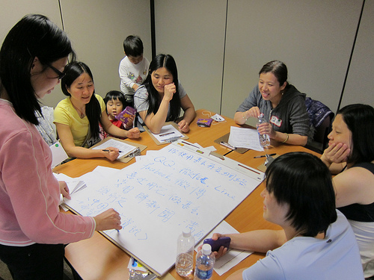Focus group respondents indicated overall low levels of education and income. About half reported less than a high school education and one-third have finished high school. Two have completed some college and one, some post graduate work. Survey respondents were diverse in age, with one-fourth between 26 and 35 years, 35% between 36 and 50 years, 10% 51 to 64 years and 30% 65 or older. About three-fourths reported income of less than $20,000 per year.

**Summary**

Access to computers and the Internet is *very important* to this group. They want access to the information and opportunities provided by the Internet, but for about a quarter, lack of sufficient knowledge about these technologies, and sometimes lack of opportunity excludes them. Many mentioned that English-only sources often make it difficult for them to understand relevant materials, and that it is hard to access translated webpages linked from English-only pages, and even to find and to use websites that teach English. Nearly all of the participants report using a computer, though their detailed responses clarified that about a quarter of the participants do not know how to use computers (even if they have one at home), but most *very much want to learn*. The cost of home Internet access is a concern reported by several, and some participants with smart phones do not have a data plans solely because of the cost.

Thus, *cost of access* is a *major barrier* to computer use in this community, as is their inability to find and to use translated websites. Participants suggested that more support for CISC for these purposes, and possibly, more CISC presence in different neighborhoods would be helpful to them.

We found that issues specific to this community will arise if the City attempts to link to them via the most common social media vehicles: these participants use social media, but not Facebook or Twitter. Instead, they use QQ – both because it is allowed in China and because participants don't experience the language barrier. However, even with QQ, the technology barrier is an obstacle to use for about a quarter of the participants.

Many participants commented that their current Internet service is too slow, and the group was also quite interested in plans for super high speed Internet access. However, participants also voiced concern about the cost of service, threats to security and privacy (including threats from the government), and persistent language barriers. Some participants suggested that high speed Internet access might help to overcome language barriers by providing a means of instant translation, or ready access to effective translators, and to online English language classes. They expressed interest in using the service to learn new skills, to keep in touch with friends and family, and to keep an eye on things at home. Some people expressed an interest in online medical appointments.

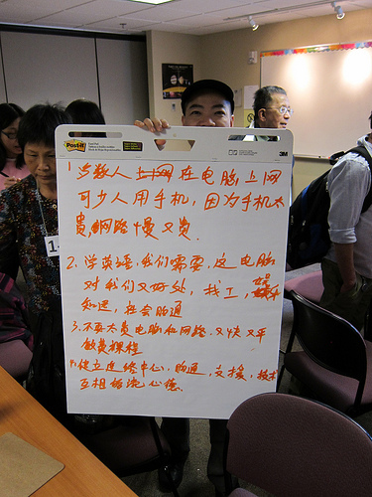Participants consistently named CISC as an *important resource* for a variety of reasons -- for getting and giving information, for accessing computers, and for learning how to use them. Respondents were appreciative of this session in the community, and revealed a strong theme of wanting the government to come to the community regularly to communicate directly with residents – suggesting a format similar to these focus groups.

Based on these sessions, our impression is that the city needs to communicate more effectively about resources that are already available. For example, most seemed unaware that many pages of Seattle.gov are translated into Chinese and that the City already provides a translation service for callers using the main city number (206 684 2489). Without English skills, many of these participant rely on bilingual friends and relatives, and community organizations such as CISC. However, if these individuals or organizations aren’t themselves aware of the City's efforts to address language barriers, even eager citizens remained uninformed. Table facilitators suggested that an e-mail list including restaurant and grocery store proprietors, would be very helpful, particularly if it were incorporated into a campaign about the City's outreach to non-English-speaking immigrants.

The city might also consider adding a link to QQ and to Chinese TV and radio to Seattle.gov, and the Seattle Channel may want to enhance their programming to non-English speakers, and links to videos featuring training in the use of computers and the Internet, and in English language skills.

**Technology Access and Use**

Of the 18 participants who responded to the *survey* question about home electronics, about a quarterhave a landline (and most of these also have a cell phone). Two-thirds have a cell phone; for 22% this is a smart phone. Only a fifth of these respondents use their cell phones to text. About three-fourths (78%) say they have a computer at home - a laptop for 61% and a tablet for 22%. As mentioned above, some people with smart phones do not have a data plan because of the cost.

Nearly all of the survey respondents (93%) say they use a computer, and 81% said they use a computer or the Internet at home. At least 65% are Internet users. More than half (56%) say they use email attachments. In the *Mutual interviewing* results, it became even clearer that those who do not have home Internet access want it. Participants say what they like best about computers or the Internet is getting information or learning (58%) with some people mentioning specifically getting news; contacting friends and family (50%); entertainment (42%); and keeping up with their kids' school information (25%). Several people, including some who already use the Internet, talked about wanting to enhance their computer skills, and their reports talked about the advantage of using a computer to find a job, entertainment, information, and social communication.

In another survey question, respondents were asked why they or others don't use computers or the Internet. Their answers corresponded to mutual interviewing notes: 65% said that computers are too expensive and nearly as many (55%) said that Internet service is too expensive. A quarter noted concern about computer-related security or safety for children (20%), and fewer (15%) said that people without computers or the Internet just don't know about it.

The survey shows that most (53%) get Internet through DSL, a few (16%) through cable, and 10% through a smart phone data plan or some other way. About one in five (21%) does not have home Internet access. Just over one third (38%) said they use the computers at the library and a quarter noted their use of a Community Technology Center. Participants are very appreciative of and positive about the CISC computer lab. As one person put it: "It is more ideal to have a tutor guidance in community center."

Figure 1 shows the different ways that respondents reported using computers. Most often, people use the Internet to find information, especially health and community-related, or to watch TV.

Nearly half (44%) reported they were not at all or not very skilled with computers. Although no one claimed to be "expert," a quarter said they are "skilled" and sometimes help others. About two-thirds of those with home Internet access say it isn't good enough for their needs. Their concerns were that it is too slow, too expensive, or unstable. Only four respondents said that they do NOT have problems using computers and the Internet. The non computer users explained that they don't use computers because they don't know how or can afford the cost of the Internet (or both). *Mutual interviewing* results are similar in that more participants are dissatisfied with their Internet speed than its cost. When asked what would most improve their Internet service, about half checked "speed" and a quarter checked "price." "Customer service" was important to 20% and Internet reliability was indicated by 15%.

**Problems using computers and the Internet**

* Don't know how to use
* Expensive Internet service
* Expensive and slow
* Sometimes will disconnect with no reasons or the weather is bad. The network is not stable.
* I like to own a computer and Internet service so I learn
* Because of poor English, difficult to learn.

The report out from this group argued for a community-based technical support and assistance center to assist novices, and to help people solve problems as they continue to use the technology. They said this service would "Establish information center, communicate, assistant, skill, exchange idea and information"

All of the respondents who answered this question were willing to spend something (no more than $20-$30) for Internet access or for faster access. Just over a third checked a box indicating between $5 and $10 per month or less than $5. Most commonly, respondents checked $10-$20 per month (43%) and about half as many checked $20-$30 per month.

In the debrief session following the focus group, one table facilitator explained that participants are especially uninterested in paying high Internet fees because they believe (accurately or not) that the service that costs $20 per month here, costs only $1 per month overseas, because of competition.

**High Speed Internet**

Nearly all (90%) of the participants expressed an interest in super high speed Internet, though several mentioned concerns with the possible cost of the service (42%), language barriers (26%), their lack of sufficient skills with computers or the Internet (26%), lack of computer (21%), and concerns with privacy (16%).

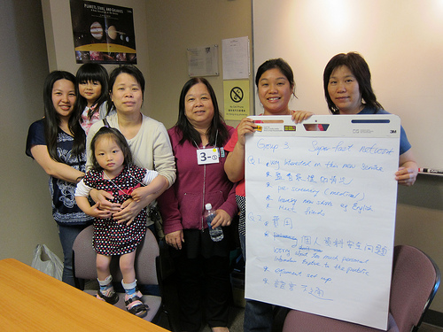Some of the uses for super high speed Internet included: studying or learning (including learning English) (37%); getting "instant" news and information (21%); home surveillance (16%); keeping in touch with friends and family (16%); medical visits (16%); shopping (10%); and work, parenting meetings, applying for a driver's license, and access to a fast translation tool (5% each).

In the debrief session following the focus group, one table facilitator thought that interested respondents may be afraid that they won't be able to learn it and are concerned about the cost.

**Cable TV and Video Content**

Very few (6%) of the focus group participants have Cable TV. When they ranked how they prefer to watch TV programs or movies, 40% of the respondents ranked "Over the Internet," first and another 5% ranked it as the second most preferred. Free TV was the second most highly ranked way of watching TV or movies, with 30% ranking free TV first and another 5% ranking it second. Next was satellite, selected by 20%, followed by cable TV.

Since few respondents indicated having cable TV, it is not surprising that only four participants rated their satisfaction with this service. Three of them were satisfied with their cable reliability and customer service, but only two were satisfied with the cost.

The few Cable TV customers were most likely to select "price" and "customer service" and the one thing that would most improve their cable TV service.

Many of these participants have incomes of less than $20,000 per year and about one-third are 65 or older. Some may qualify for reduced fees for cable service, but they may be unable to access this benefit because of the language barrier. If the community organizations that serve them, such as CISC, is not aware of this benefit, the participants would not be aware, either.

**Seattle.gov and The Seattle Channel**

One-third of the respondents have visited the City's website and 60% have seen the Seattle Channel. Three-fourths of those watched it on cable and one-third over the Internet (and one on both). Much of their behavior, venues, and habits is shaped by their seeking Chinese-language programming: in mutual interviewing several participants mentioned the importance of AATV in Chinese, and others asked for local English news with instant Chinese translation.

In the debrief session after the focus group, table facilitators remarked that participants want more free classes and they want to know more about Seattle (including where in Seattle it is safe for their children) but they note that it is inconvenient for some of the participants to travel from home to CISC, and CISC is in limited locations.

Some participants commented that they cannot access the Seattle.gov website because it is all in English. None of the participants commented on the translated pages in Seattle.gov, suggesting that they may not be aware of it or may not be able to find it if they access the website.

**Social Media**

One of the *mutual interviewing* groups focused on the use of social media. About three-fourths of the participants said they use a social networking program, with about two-thirds mentioning QQ. Three (18%) mentioned Facebook, two mentioned Skype and one mentioned LinkedIn. Of those who don't currently use a social networking program, 71% want to. Of those who don't use it, 63% say it is because of lack of equipment or they don't know how.

The survey asks how often they use email, Facebook or Twitter, but did not include QQ. Of those listed, email is the most commonly used by far. Even so, only two-thirds use it at all, and 40% check at least daily. At least half indicated that they don't use Facebook at all. Among the seven individuals who *are* Facebook users, four said they check it daily, and the other three said "weekly." Twitter is used by fewer people yet, with 10 saying they don't use it. Of the five who do use it, four use it daily and one weekly.

In *mutual interviewing*, participants said they like to use their social networking program for:

* communicating with other people (40%)
* entertainment (26%)
* getting news (26%)
* studying or learning (20%)

Participants also expressed their concerns with using social media, of which only one (language barrier) related to the program itself:

**Dislike about social media**

* Sometimes not clear and no sound and don't know how to use.
* Security, advertisement, always change privacy policy without notices
* Internet speed slow, expensive Internet fee, continuously increase fee
* All information is in English, no Chinese version.
* slow Internet speed (62%)
* cost of Internet service (31%)
* not in Chinese (15%)

Interviewers explored the possibility of using social media to communicate with government. Participants were fairly positive, but expressed a few concerns, especially the language barrier (42%) and lack of necessary skills (21%). A few (15%) preferred other ways of communicating (telephone or letter). One person provided this response, "Won't. As I said, Facebook is just for social network. I don't want to expose my person life to the government."

In the debrief session following the focus group, the table facilitator confirmed that the Chinese community does not use Facebook or Twitter. Instead, they use QQ because it's a program that is allowed in China.

**Communicating with Government**

In a more general question about communicating with government, survey respondents were asked to check as many boxes as they wish to indicate how they would like to give opinions to the City on issues they care about. Figure 2 illustrates the pattern of responses with "community meeting" the most commonly selected response. About one-third selected a telephone survey and nearly as many (26%) selected "discussion on the Internet." Only 11% selected "email or online survey," however, email is more popular as a way of generally making contact with the government, selected by 56% of respondents, slightly more often than by telephone (selected by half) or in person (selected by 39%). A few people would text (28%), fewer still write a letter (17%) and one person indicated that they prefer to make contact via social media (Facebook or Twitter).

When asked what the city could do better to help get important information into the Chinese community, about a quarter of the responses related to overcoming the language barrier.

**What would make it easier to participate in improving the community?**

* Often have face to face communication with citizen (with interpretation)
* Through AATV, English community news with instant Chinese translation.
* Make Chinese newspaper better.
* Through CISC, similarly like today. Government is talking to us face-to-face.

In *mutual interviewing*, about half of the respondents suggested giving their opinions through some type of direct community contact (with Chinese interpretation), and half of these explicitly suggested that such community contact happen through CISC. Another quarter also mentioned CISC, but not explicitly in the context of hosting a community meeting. About 20% asked the government to come to their community on a regular basis to collect their advice/feedback, "Hope government can collect feedback/advice from the community on a regular basis or someone from the government can meet us directly." Not as many (16%) suggested email (in Chinese) or an online strategy and fewer suggested the telephone (11%).

The survey offered a list of possible ways to get information they care about from the City and participants were allowed to check any that would work for them. Figure 3 shows that most people in this group want to get their information from the City via TV news (70%). Most of these also selected "the Seattle Channel" (45%). Otherwise, respondents rely on word of mouth from other community members or the newspaper (both 35%). Overall, 30% selected some Internet-based communication strategy, including email (30%), the City's website (10%), or Twitter (5%). None of the respondents selected Facebook for this purpose.

In *mutual interviewing*, about half of the participants mentioned CISC as a way of getting information from the government. About 60% mentioned media, including Chinese TV (about one-third - two people specifically named Chinese AATV), radio (11%), Chinese newspaper (one-third). Language was mentioned as an important factor by 37% across the different strategies. Additionally, 26% mentioned some Internet-based communication strategy, including online news and Seattle.gov.

In the debrief session the table facilitators mentioned that seniors in particular get their information in restaurants, picking up available reading material as they sit there. However, they noted that the content in the Chinese newspapers is from Hawaii or California. This facilitator explained that it is convenient for participants to receive important information from the City in a letter because if she does not understand the meaning of the letter, she can take it to CISC or to a friend for help in understanding it. However, because of limited capacity at CISC, this can be a time-consuming process.

Facilitators described some types of information that would be very important to have in Chinese as well, including bus schedules and radio announcements about school closures due to snow. One facilitator described a participant who shops only at Uwajimaya because she can read the ingredients on those labels, and can get help from the staff.

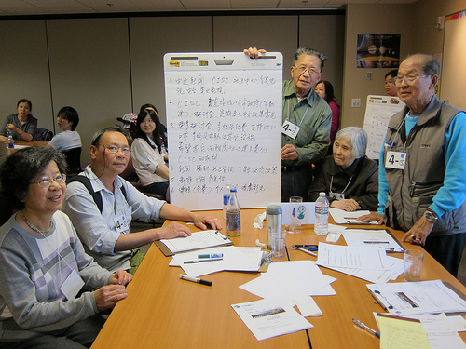**Learning**

In *mutual interviewing*, participants said they are interested in learning. About one-third asked for help in learning to use computers, and somewhat more (about 40%) want help in using the Internet, naming specific interests like being able to access news and community information, getting information about available benefits, and children's education. About 10% are interested in learning about social networking programs, and as many would like to use the Internet to improve their English language skills.

The table's report out indicates that participants want free seminars with individual training and video. Several asked for more computers and more learning opportunities at CISC.

In the debrief session after the focus group, one table facilitator ventured that language is the most difficult barrier to overcome. Participants believe that they can't use the website because it is not translated and they have no idea what the Internet can do. This person believes that those without access to the Internet and without a computer also don't want to learn, possibly because of the expense in both time and money.

|  |  |
| --- | --- |
|  | See the full report with other focus groups and survey results at Seattle.gov/tech/indicators   City of Seattle Department of Information Technology  Community Technology Program |